Ex.No : 6 | MongoDB Atlas
06.04.2021 | MongoDB Atlas

Aim
To create a cluster in mongodb atlas and access database via node.js.
Procedure
- Create an account on https://cloud.mongodb.com/ and login.
- Create an organization.
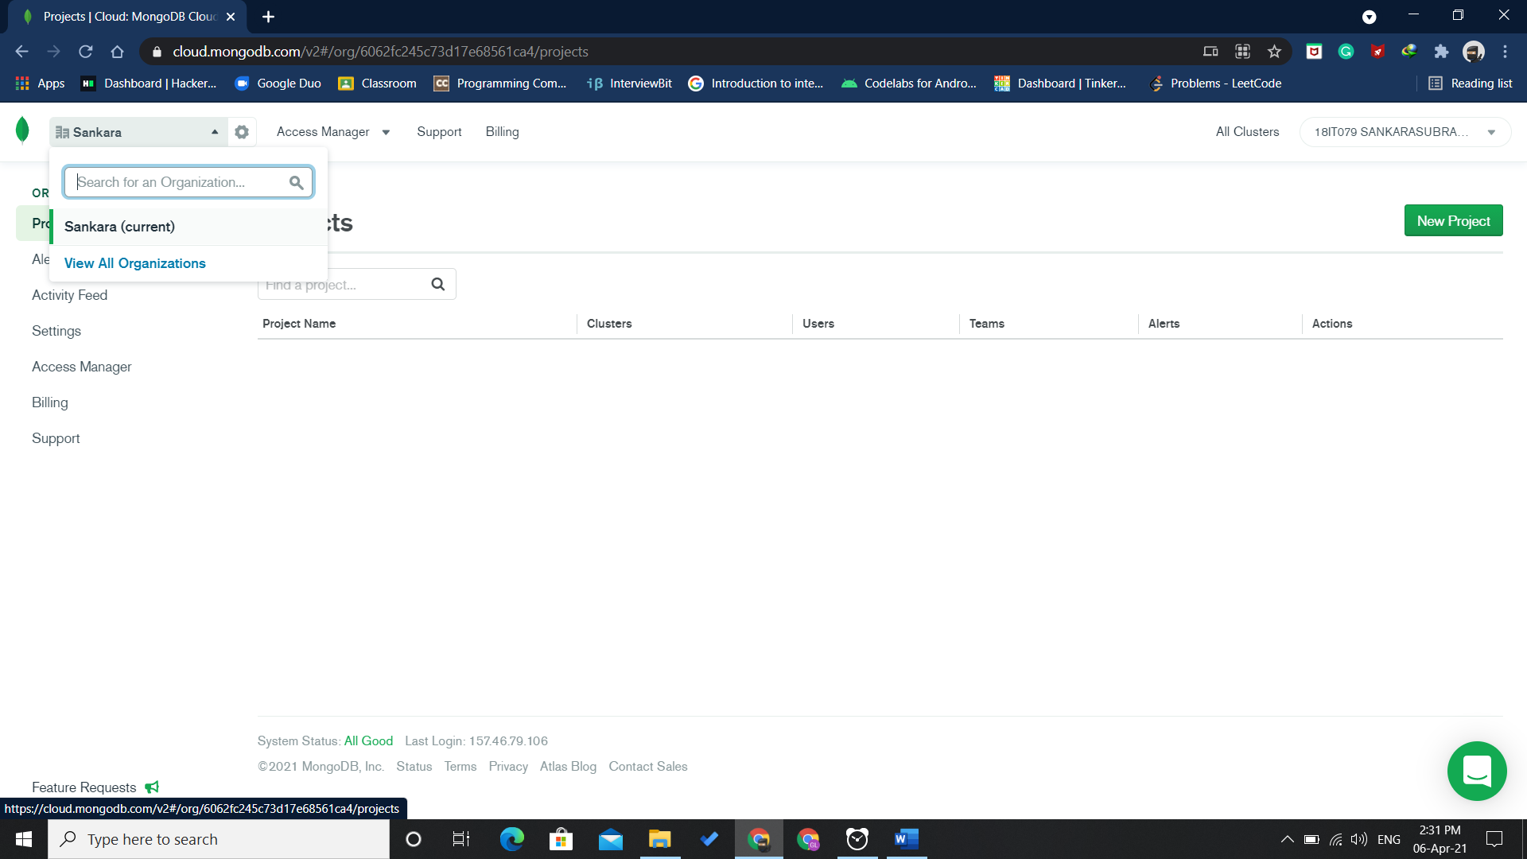
- Create a new project.
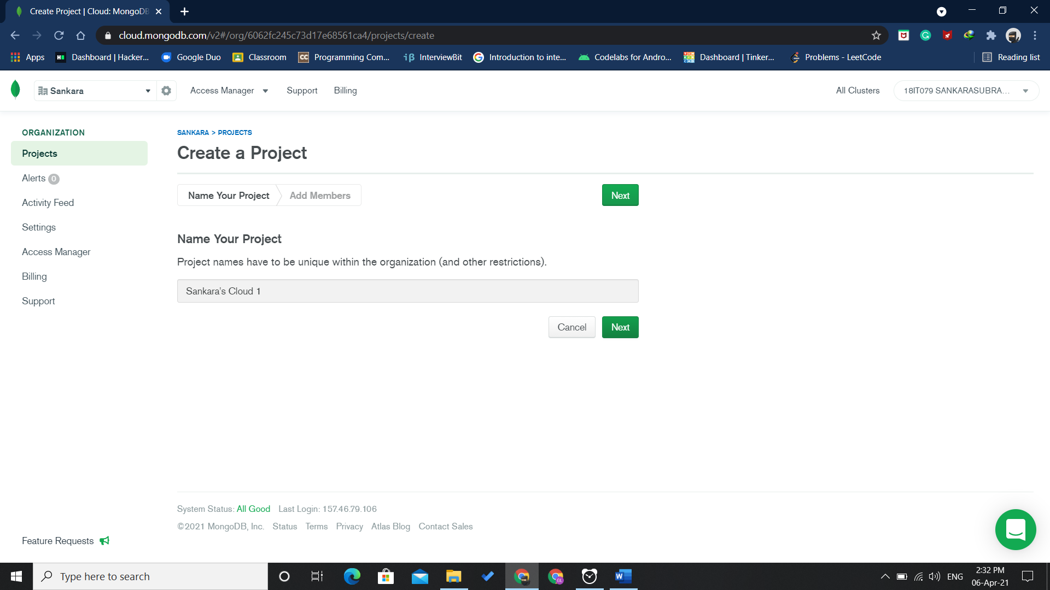
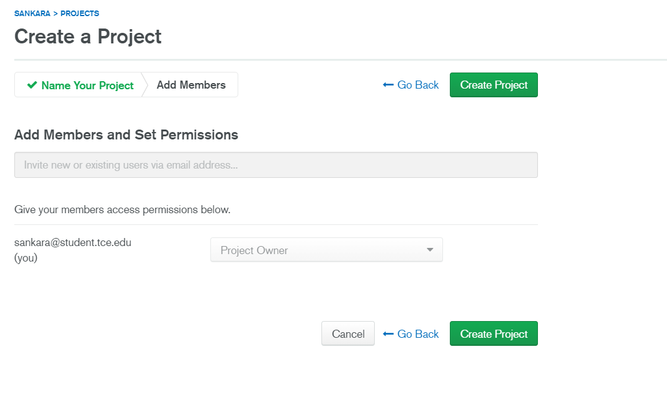
- Create a new cluster(Shared M0) after the project is created.

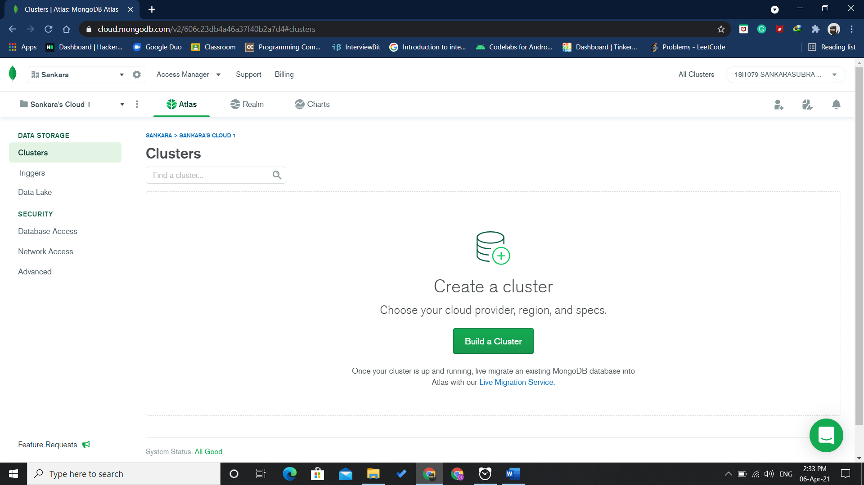
- Select the required fields and create cluster.
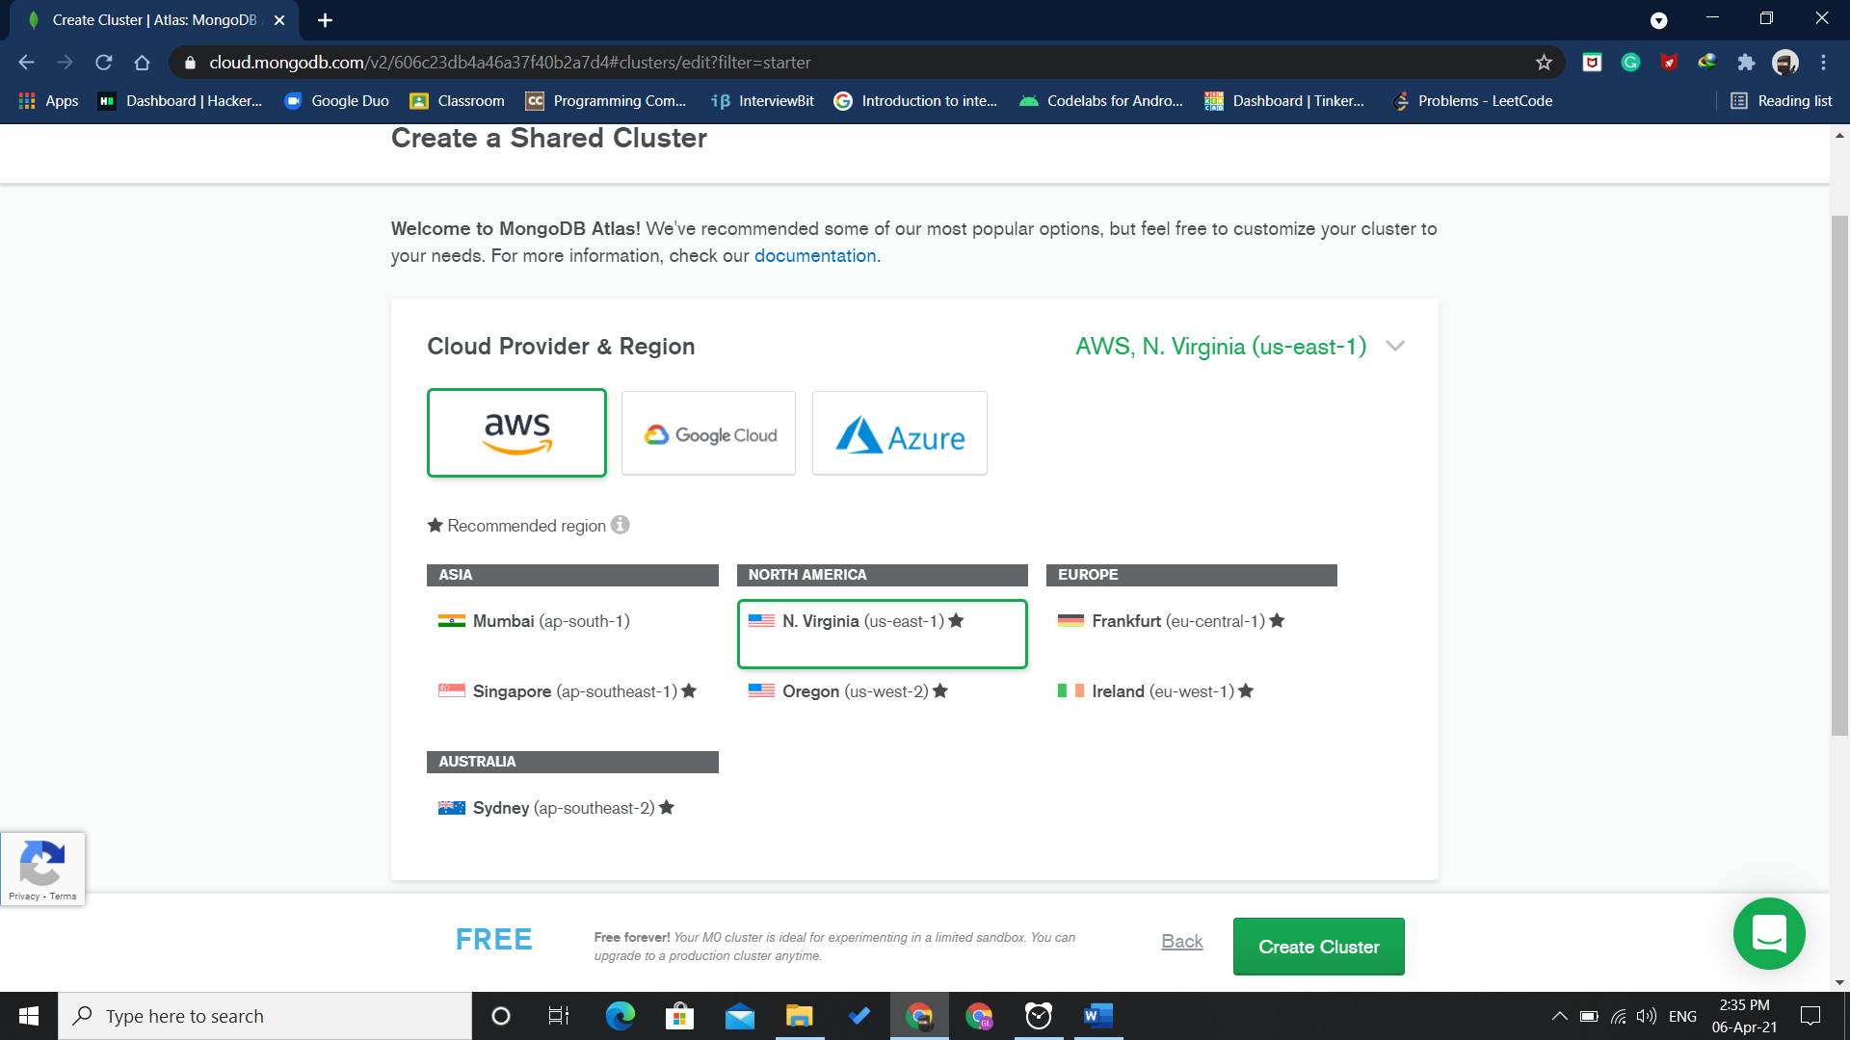
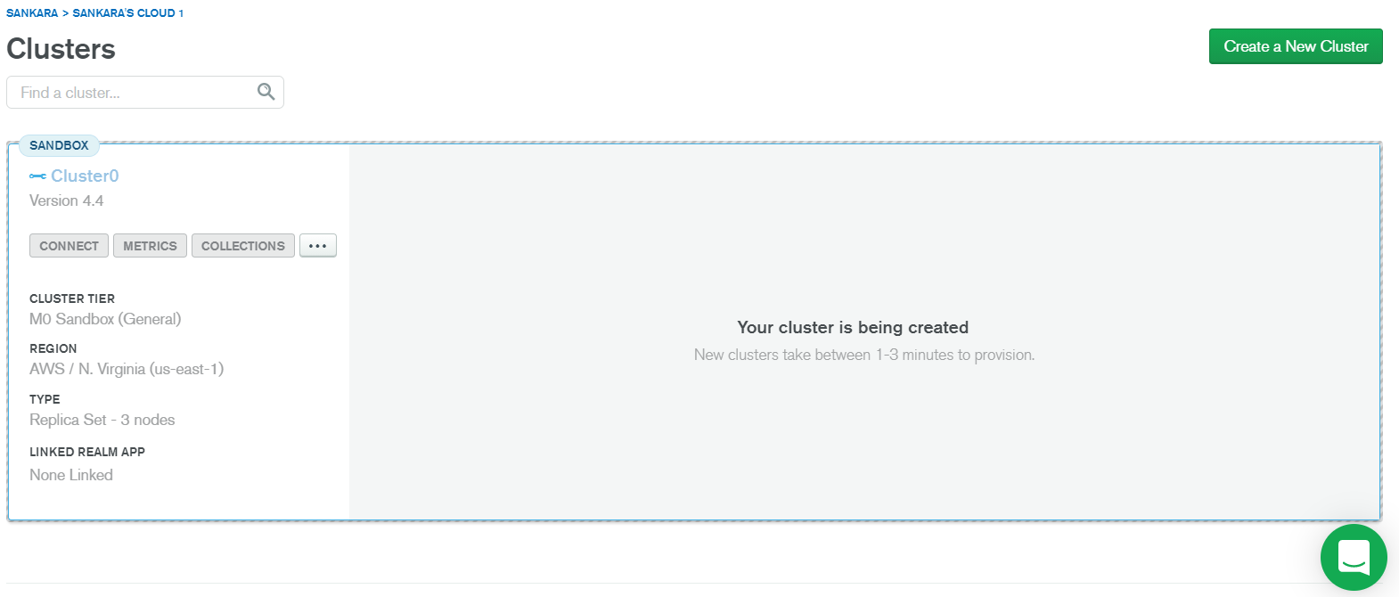

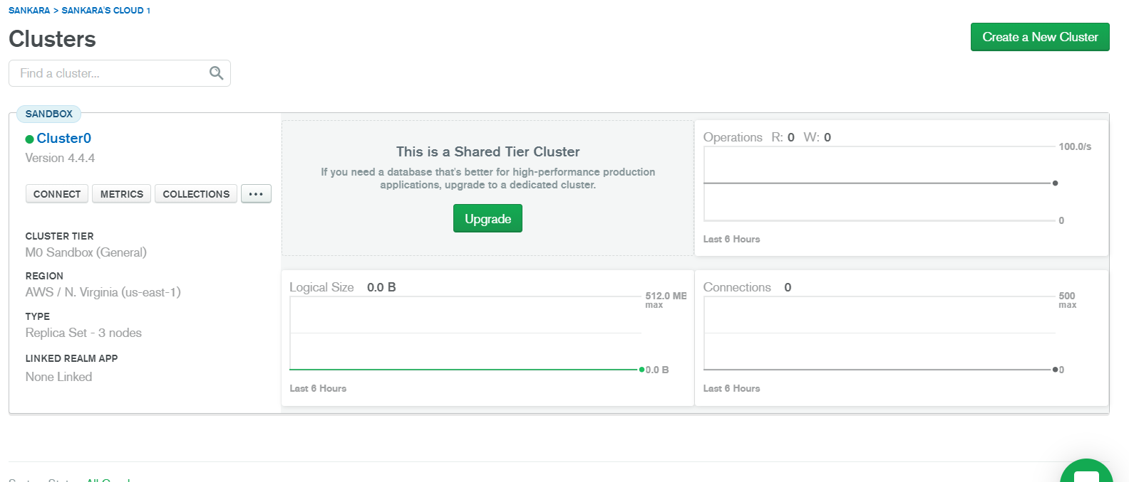

- Load the sample dataset into the collection
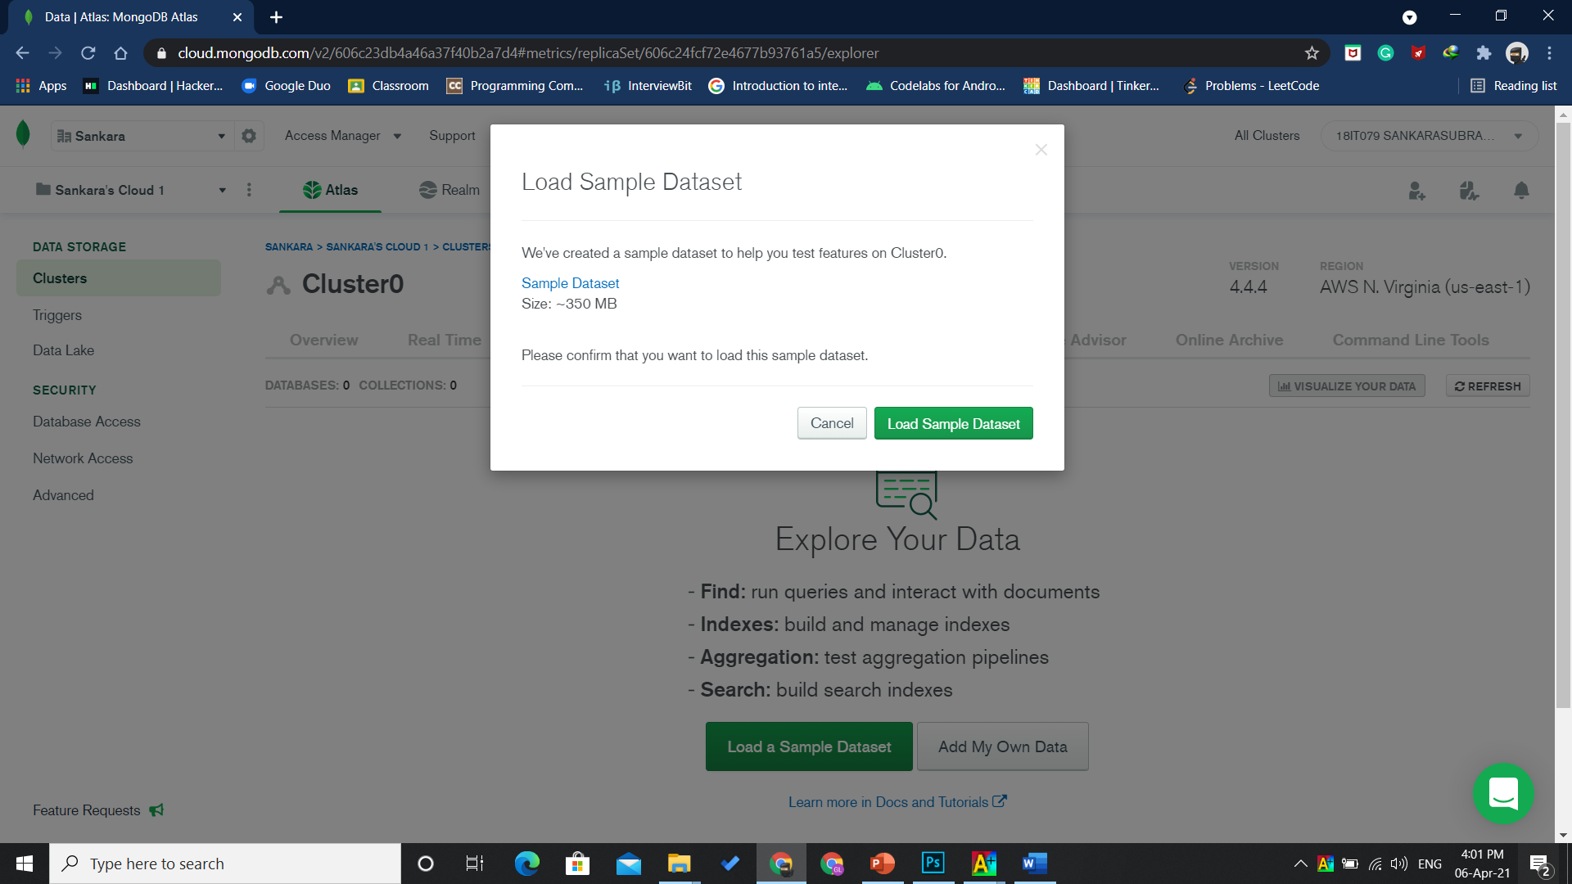
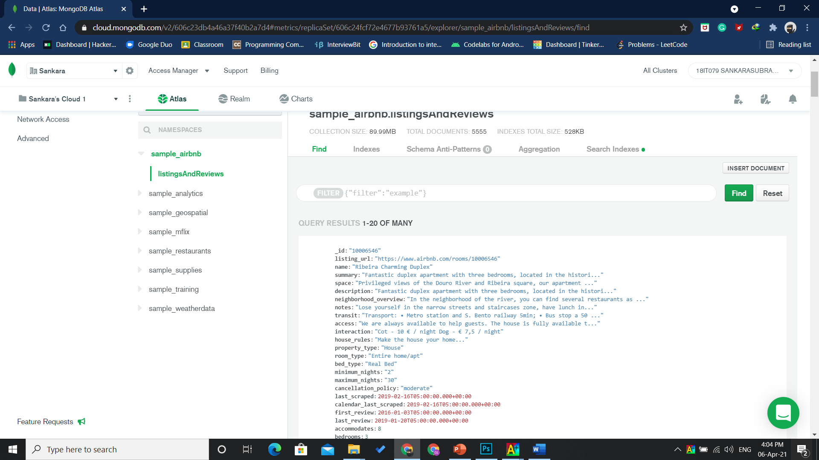

- Add IP address and Create database user.
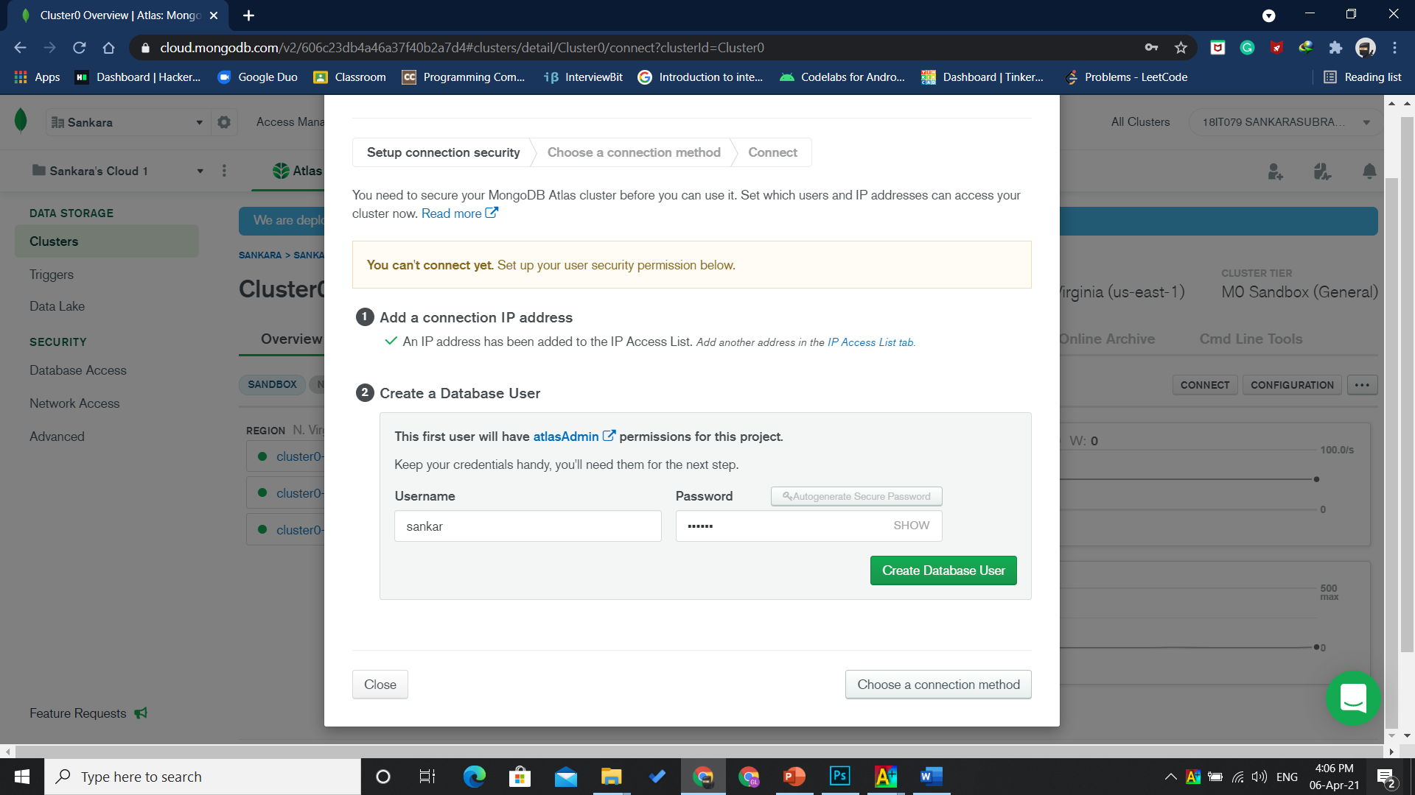
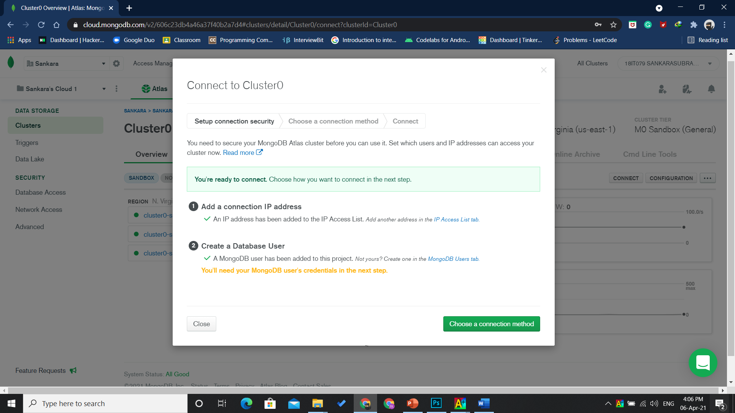

- Connect your application to the cluster.
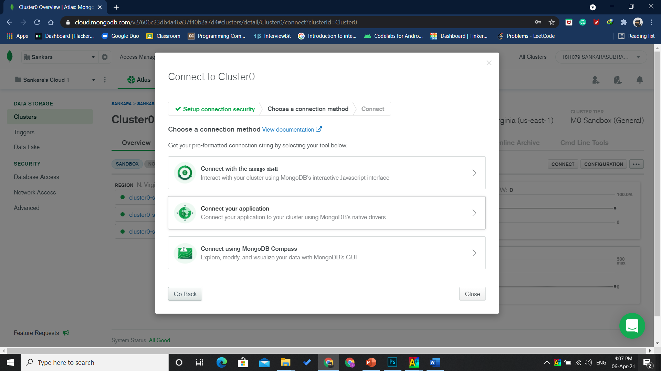
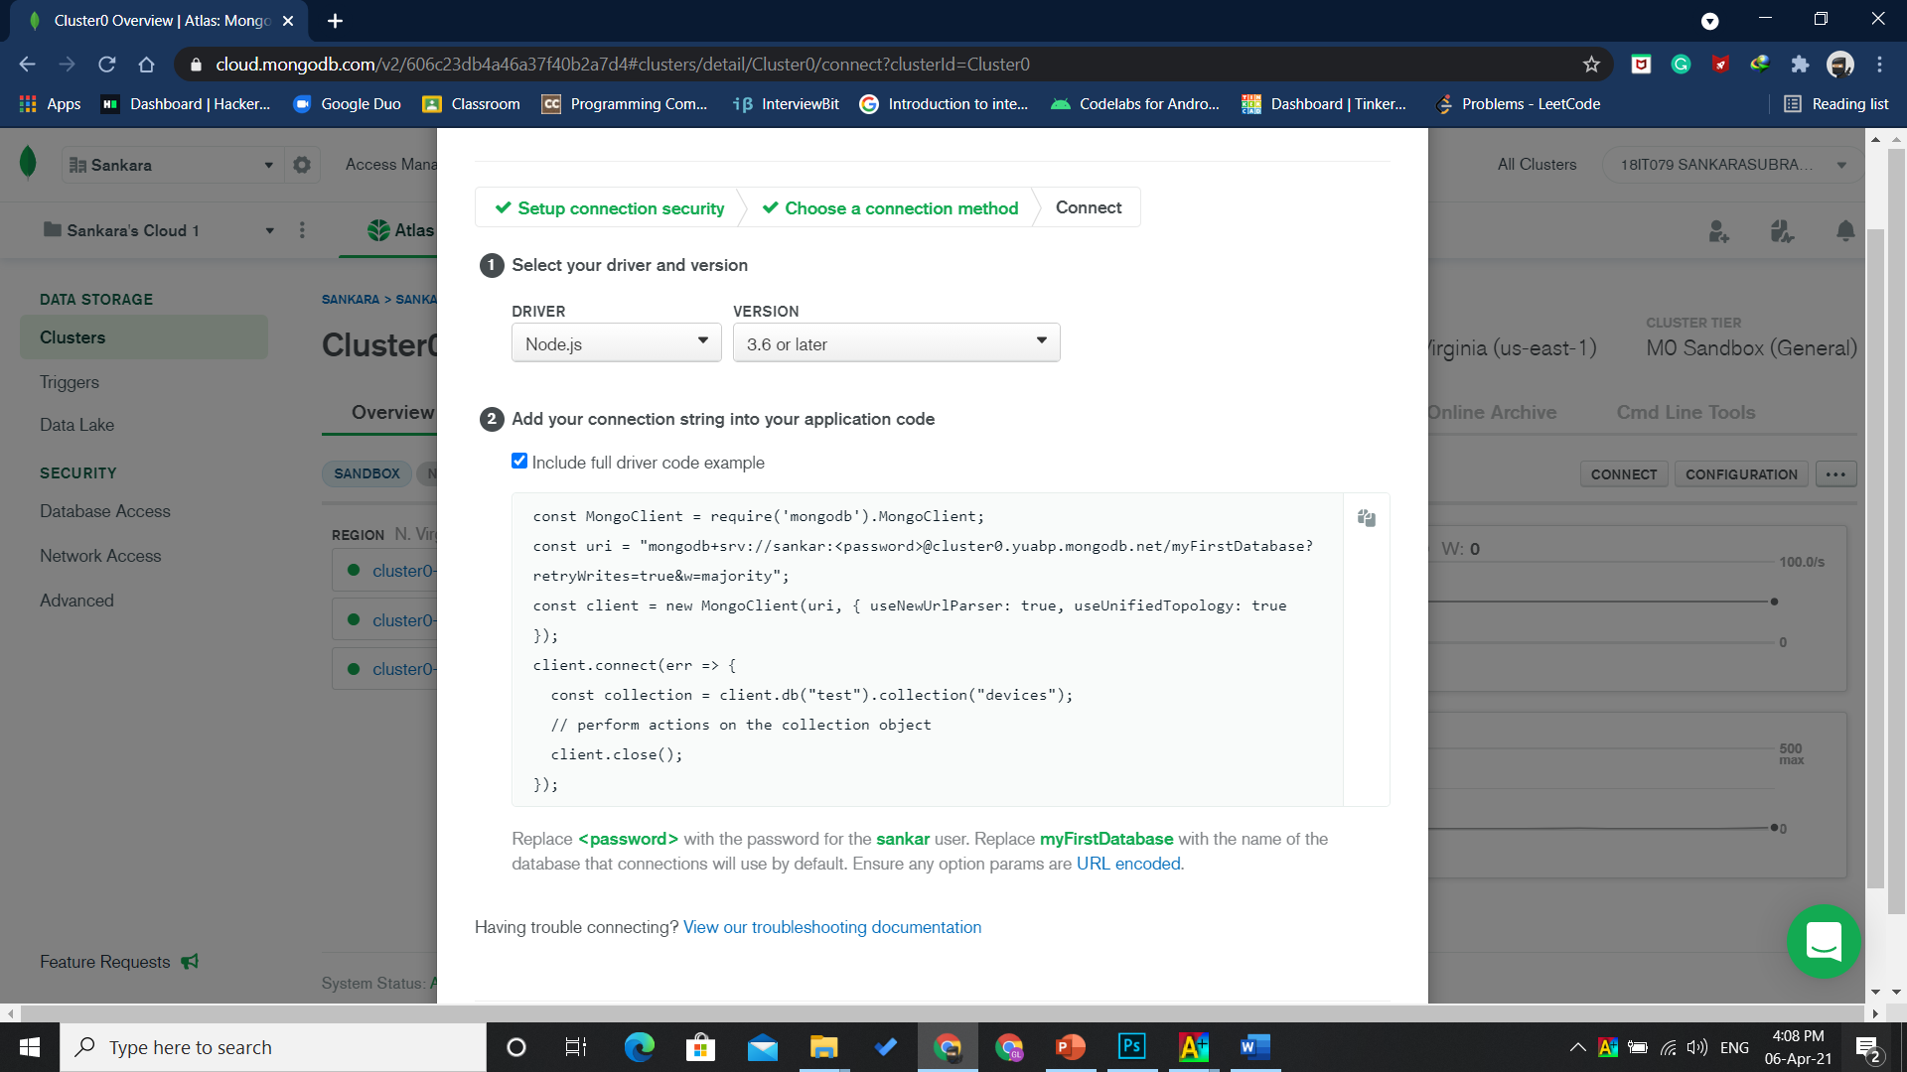

- Perform some operation from node js and run to see the result.
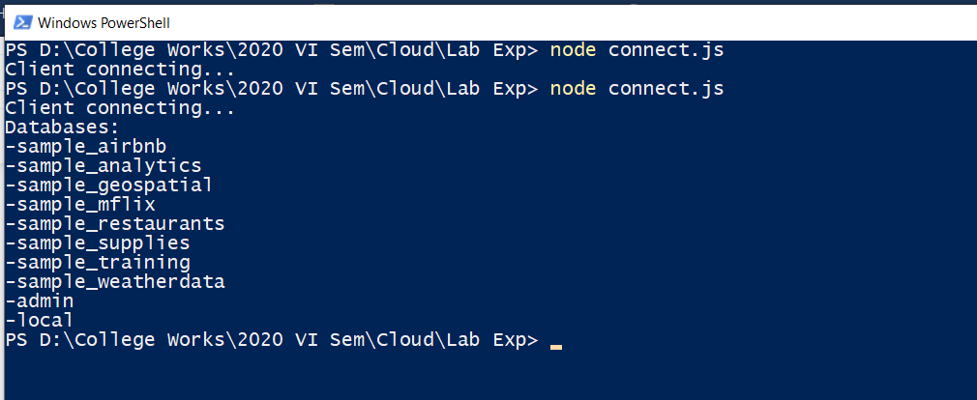

Result
Thus, application is connected to mongoDb atlas via node js and the result is obtained.

